Protection of the Virgin Mary
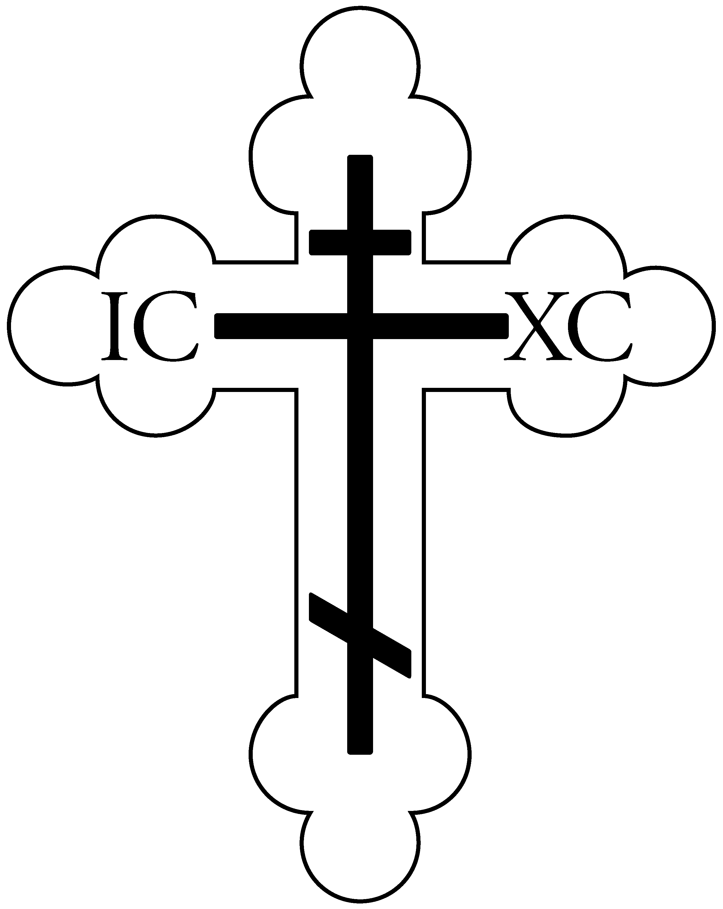
Orthodox Church
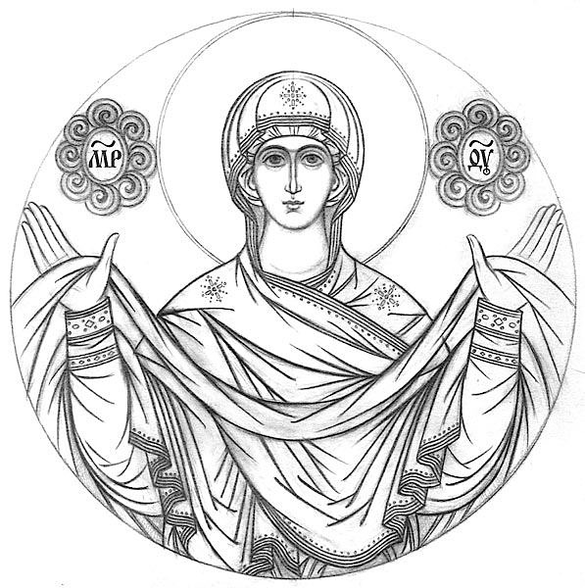
A Parish of the Diocese of Chicago and the Midwest Orthodox Church in America
8600 Grand Blvd.
Merrillville, IN 46410
(219)947-4748
Hall: (219)730-4698
www.ptvm.com

Rev. Dr. Jacob Van Sickle

(219)384-6826 • frjacobvansickle@gmail.com

May 10, 2020
Sunday of the Paralytic
Fourth Sunday of Pascha

Hymns of the Day

Tone 3 – Resurrectional Troparion
Let the heavens rejoice!
Let the earth be glad!
For the Lord has shown strength with His arm.
He has trampled down death by death.
He has become the first born of the dead.
He has delivered us from the depths of hell,
and has granted to the world//

great mercy.

Tone 3 – Kontakion for the Paralytic

By Your divine intercession, O Lord,

as You raised up the Paralytic of old,

so raise up my soul, paralyzed by sins and thoughtless acts;

so that being saved I may sing to You://

“Glory to Your power, O compassionate Christ!”

Tone 8 (Special Melody) – Kontakion of Pascha

You descended into the tomb, O Immortal,

You destroyed the power of death.

In victory You arose, O Christ God,

proclaiming: “Rejoice!” to the Myrrhbearing Women,//

granting peace to Your Apostles, and bestowing Resurrection on the fallen.

Scripture Readings

Tone 1 – Resurrectional Prokeimenon (Psalm 32)

Let Your mercy, O Lord, be upon us / as we have set our hope on You!

Acts of the Apostles 9.32-42
Now in those days, it came to pass, as Peter went through all parts of the country, that he also came down to the saints who dwelt in Lydda. There he found a certain man named Aeneas, who had been bedridden eight years and was paralyzed.
And Peter said to him, “Aeneas, Jesus the Christ heals you. Arise and make your bed.” Then he arose immediately. So all who dwelt at Lydda and Sharon saw him and turned to the Lord.
At Joppa there was a certain disciple named Tabitha, which is translated Dorcas. This woman was full of good works and charitable deeds which she did. But it happened in those days that she became sick and died. When they had washed her, they laid her in an upper room. And since Lydda was near Joppa, and the disciples had heard that Peter was there, they sent two men to him, imploring him not to delay in coming to them. Then Peter arose and went with them. When he had come, they brought him to the upper room. And all the widows stood by him weeping, showing the tunics and garments which Dorcas had made while she was with them.
But Peter put them all out and knelt down and prayed. And turning to the body he said, “Tabitha, arise.” And she opened her eyes, and when she saw Peter she sat up. Then he gave her his hand and lifted her up; and when he had called the saints and widows, he presented her alive. And it became known throughout all Joppa, and many believed on the Lord.
Gospel: John 5.1-15
At that time, there was a feast of the Jews, and Jesus went up to Jerusalem. Now there is in Jerusalem by the Sheep Gate a pool, which is called in Hebrew, Bethesda, having five porches. In these lay a great multitude of sick people, blind, lame, paralyzed, waiting for the moving of the water. For an angel went down at a certain time into the pool and stirred up the water; then whoever stepped in first, after the stirring of the water, was made well of whatever disease he had.
Now a certain man was there who had an infirmity thirty-eight years. When Jesus saw him lying there, and knew that he already had been in that condition a long time, He said to him, “Do you want to be made well?”
The sick man answered Him, “Sir, I have no man to put me into the pool when the water is stirred up; but while I am coming, another steps down before me.”
Jesus said to him, “Rise, take up your bed and walk.” And immediately the man was made well, took up his bed, and walked. And that day was the Sabbath.
The Jews therefore said to him who was cured, “It is the Sabbath; it is not lawful for you to carry your bed.”
He answered them, “He who made me well said to me, ‘Take up your bed and walk.’”
Then they asked him, “Who is the Man who said to you, ‘Take up your bed and walk’?” But the one who was healed did not know who it was, for Jesus had withdrawn, a multitude being in that place.
Afterward Jesus found him in the temple, and said to him, “See, you have been made well. Sin no more, lest a worse thing come upon you.” The man departed and told the Jews that it was Jesus who had made him well.

We Remember in Prayer

NDep. Joseph Clark

Wayne Fritz

Ev.Mem. Gabriel Nush (’23)

Stavre Petroff (’56)

John Melnikow (’57)

Evdokia Basalay (’58)

Mary Krochta (’59)
Health/Salvation:
Archpr. Peter
Pr. John
Pr. Christopher
Mat. Jennifer
Andrew
Gideon
Dn. Nicholas
Kevin
Jon
Tanya
Jovan
Julia
Warren
Carol
Tom
Elizabeth
Tina
Brittany
Jennifer
Lennox
Laila
Paula
Melissa
Jonathan
Matthew
Gail
Maria
Stacy
Jeramie
Olivia
Parker
Barbara
Thomas
Jessica
Eduardo
Christine
Nicholas
Natalie
Barbara
Kristin
Linda
Phyllis
Kay
Fred
Larry
Rollie
Joseph
Mark
Alexa
Paula
James
Joanne
Michael
Joseph
Kathleen
Paul
William
Frederick
Janet
Lea
Hania
James
Gerald
Nadia
Charlene
Milka
Daniel
Russell
Brendan
Benjamin
William
Kara
Nathan
Sharon
Michael
John
Miriana
Vern
Janice
Olga
Claudia
Mark
Jerry
Daniel
Joanna
Myah
Michael

*If you know someone who needs prayer, please give their name to Fr Jacob

In place of “It is truly meet…” we sing the following:

The angel cried to the Lady full of grace: ‘Rejoice, O pure Virgin!
Again I say: Rejoice! Your Son is risen from His three days in the tomb!’
With Himself He has raised all the dead! Rejoice, rejoice, all you people!
Shine! Shine! Shine! O new Jerusalem! The glory of the Lord has shone on you!
Exult now, exult and be glad, O Zion!
Be radiant, O pure Theotokos, in the resurrection, the resurrection of your Son!

We sing “Christ is risen…” in place of “We have seen the true Light...”
At the Dismissal, the priest says “Glory to You, O Christ…” and the choir sings “Christ is risen…” three times.

Tone 8
And unto us He has given eternal life.
Let us worship His Resurrection on the third day!

Announcements

We have put together a parish email list for keeping in touch during this time of isolation. If you are not receiving emails, please send your email address to ptvmchurch@gmail.com to be added.

For Bible Study on Wednesday read Acts 1-2. If you would like to participate but haven’t before, email Fr Jacob.

St. Mary’s O-Club is partnering with our own Sergei Ely’s Pierogi truck to bring hot meals to workers at local nursing homes during the health crisis. Their first delivery to Miller’s Merry Manor in Hobart this past Friday was a great success. Thank you to our volunteers and sponsors. Next Monday we will deliver to Wittenberg Village in Crown Point. Anyone interested in volunteering should email ptvmchurch@gmail.com or contact Juli Grankowski or Sergei Ely directly.

On June 17 we will host a Red Cross blood drive in our parish hall. More details to come!

If anyone in our community is suffering hardship, please contact Fr Jacob. The parish has established a benevolence fund to help those in need during this crisis.

Parishioners are asked to continue their stewardship either by mail or online through the “donate” button on our website: www.ptvm.com

Our Spring Fashion Show was postponed to Friday, May 29. Doors to open at 5pm. Dinner at 6pm. (No further updates at this time)

Mark your calendars:
May 25: Memorial Day blessing of graves starting at St. Mary’s cemetery @ 9am
May 29: Spring Fashion Show @ 5pm
June 17: Blood/Food Drive

Pastoral Letter Concerning the Coronavirus
from the Holy Synod of Bishops of the Orthodox Church in America

To the clergy, monastics, and faithful of the Orthodox Church in America,

We are completing the second week of our celebration of the great feast of feasts, Holy Pascha, in which we are reminded of the blessed unbelief of Thomas. All of us have longed to touch the life-giving side of the risen Christ with an eager hand even as Thomas did when our Lord came to the apostles through closed doors. And yet, many of us were deprived of the opportunity, not only to touch His side, but even to enter the temple in order to sing: “Bless God in the congregations, the Lord, O you who are of Israel’s fountain.” (Psalm 68:26)
Our encounter with the pandemic brought about by the coronavirus came upon us in the midst of our journey through the desert of Great Lent. The struggle remains with us during the bright season of the resurrection but now we sense the fragrance of the eternal and physical spring, which brings with it the hope of good things to come. Indeed, with you, the Holy Synod of Bishops longs for the full opening of our churches, missions, monasteries, and seminaries so that we all might return to the fullness of our church life, and with Thomas, offer our worship to the Lord by crying out: “My Lord and my God!”
While the dates for a full opening are still unknown, we are convinced that the time has come for us to begin the preparatory work that will bring us closer to those days. This preparatory work will be difficult as we make our way through the spiritual, emotional, and psychological effects of isolation and quarantine. This preparatory work will also be slow, for we must test the procedures and steps that we will collectively take in restoring our church life, so that we might responsibly navigate the many challenges that will confront our communities on the local level.
Above all, we issue a spiritual call to the clergy and faithful of the Orthodox Church in America. While the spread of this virus has caused death, sickness, anxiety, and economic distress, this time has offered us, and continues to offer us, an opportunity to strengthen our prayer life, to perform works of charity, and to show compassion and love to our brothers and sisters in the Church and in our communities. All Orthodox Christians should remember in their prayers those who have fallen asleep, those who are sick, those who have recovered, those who are suffering from fear, anxiety, and distress brought upon them by this virus. Further, we should offer our prayers and sincere gratitude to all those laboring to insure the necessities of life, healthcare workers and first responders, food supply workers, and other essential occupations who have sacrificially offered themselves for the benefit of their neighbor.
The Holy Synod also provides the following fundamental principles that will guide our steps forward:
- As we have always acknowledged, each diocesan bishop is entrusted with the spiritual and pastoral care of the clergy and faithful, protecting their wellbeing as he determines necessary, while always remaining of one mind with the Holy Synod. The same principle applies in the process of re-opening the churches. Any interpretation or clarification of the following guidelines should be directed to the diocesan bishop. Decisions requiring approval of the Holy Synod will be addressed as needed.
- To provide for unity and to allow the bishops greater guidance and support regarding how and when to re-open their churches and institutions, the Holy Synod has adopted new directives for use throughout the Orthodox Church in America. This detailed document, entitled, “Towards a Re-opening of our Churches,” is provided as a reference point for the bishops and should be carefully reviewed by all levels of diocesan leadership (Chancellors, Deans, Diocesan Councils, Rectors, and Parish Councils). Implementation of these synodal directives takes place under the authority of the diocesan bishop.
- It should be understood that there may be variations in the application of these new directives. These variations will parallel those that are found among regions, states, provinces, counties, and municipalities. It is incumbent therefore upon the church leadership, under the direction of their bishop to be familiar with and understand both the civil guidelines and the Church directives that appertain to their local circumstances.
- We must continue to adhere to the civil guidelines, beginning with those of our federal governments and then the particular and localized guidelines from the civil authorities, recognizing that there is a diversity from state to state, province to province, county to county, and even municipality to municipality. While the civil authorities have been reluctant to impose restrictions on the churches, our communities are expected to respond in a way that is consonant with the public welfare. The Holy Synod, concerned for the health and well-being of all, intends to follow in the spirit in which those decrees are given.
- During these initial stages of re-opening, when church attendance will, of necessity, remain limited, the clergy are instructed to consult their diocesan bishop for direction on the celebration of the holy, life-giving mysteries of the Church (the eucharist, baptism and chrismation, marriage, etc). The Holy Synod will consider the need for further church-wide directives in these areas as the process of re-opening unfolds.
The above principles, in conjunction with the synodal directives, are offered with the understanding that they are general principles and directives that may provide for the possible opening of parishes, as long as the local conditions warrant this, and with the consent of the bishop. These are not mandatory steps that must be taken by a certain calendar date.
Finally, we note that there is much to cause anxiety in the current circumstances, from political debates to scientific quarrels and the pitting of experts against other experts. We remind the clergy and the faithful that this current pandemic is unprecedented and that even the experts, faithfully following the scientific method, must have time to gather and analyze data. In such a fast-moving situation, even these studies are provisional and subject to correction. This is the nature of the scientific model.
While being mindful of all this, we also offer a word of encouragement to our clergy and faithful by reminding them of the words of the psalmist: Thy mercy, O Lord, shall follow me all the days of my life. Let us trust the Lord to guide us, rely on each other to support and help one another, and kindle in our hearts the fire that Luke and Cleopas felt burning in themselves when the risen Lord appeared and spoke to them on the road to Emmaus.

With our paternal blessing and love,

+Tikhon
+Nathaniel
+Benjamin
+Alejo
+Mark
+Melchisedek
+Irénée
+Michael
+Alexander
+David
+Paul

Glory to God for all things!

