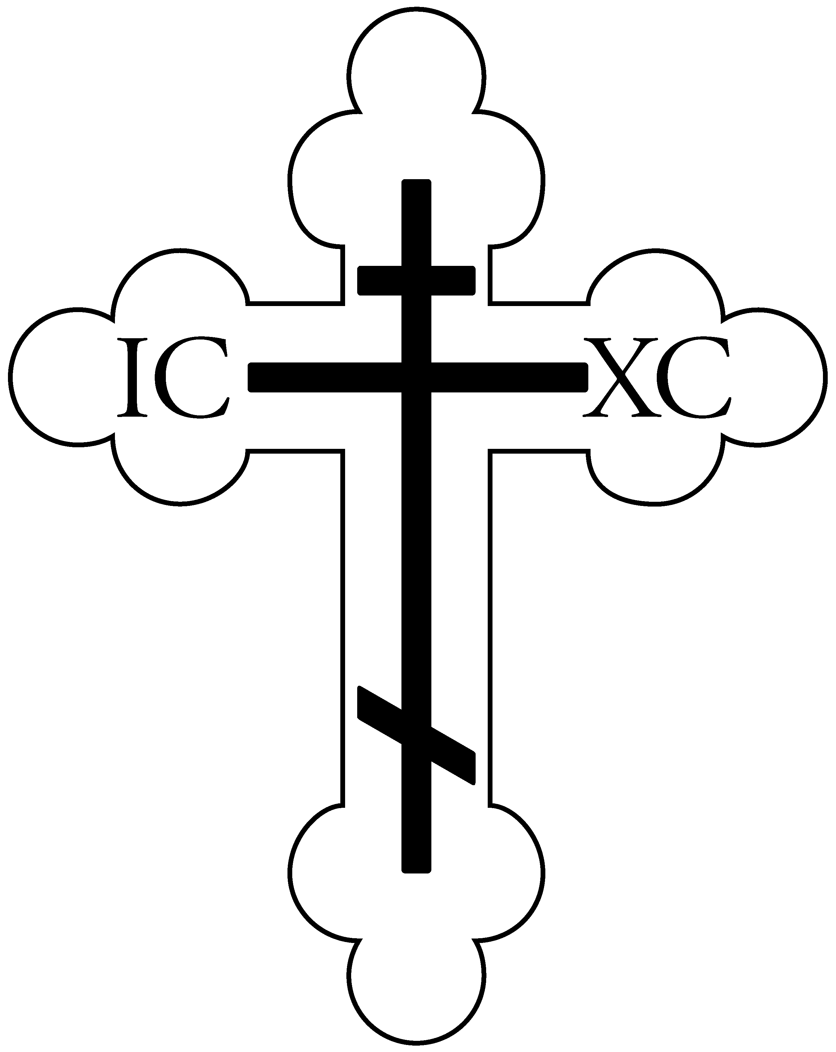
Protection of the Virgin Mary Orthodox Church
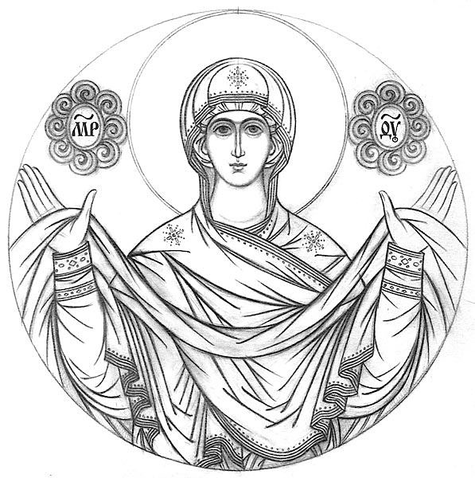
8600 Grand Blvd.
Merrillville, IN 46410
(219)947-4748
Hall: (219)730-4698
www.ptvm.com

A Parish of the Diocese of Chicago and the Midwest Orthodox Church in America
Rev. Dr. Jacob Van Sickle

(219) 384-6826 • frjacobvansickle@gmail.com
Welcome visitors! Please join us in the parish hall after Divine Liturgy for coffee hour.

Great Vespers: 6pm Saturdays

Divine Liturgy: 10am Sundays

Confessions are heard before or
after Vespers or by appointment.

May 12, 2019
Sunday of the
Myrrhbearing Women

About the beginning of His thirty-second year, when the Lord Jesus was going throughout Galilee, preaching and working miracles, many women who had received of His beneficence left their own homeland and from then on followed after Him. They ministered to Him out of their own possessions, even until His crucifixion and entombment; and afterwards, neither losing faith in Him after His death, nor fearing the wrath of the Jewish rulers, they came to the sepulcher, bearing the myrrh-oils they had prepared to anoint His body. Those whose names are known are the following: first of all, the most holy Virgin Mary, who in Matthew 27:56 and Mark 15:40 is called "the mother of James and Joses" (these are the sons of Joseph by a previous marriage, and she was therefore their step-mother), Mary Magdalene, Mary the wife of Clopas, Joanna wife of Chouza, a steward of Herod Antipas, Salome the mother of the sons of Zebedee, Mary and Martha the sisters of Lazarus, and Susanna. As for the names of the rest of them, the evangelists have kept silence. With them we celebrate also the secret disciples of the Savior Joseph and Nicodemus. Nicodemus brought some one hundred pounds of myrrh-oils and an aromatic mixture of aloes and spices out of reverence and love for the divine Teacher (Jn 19:39). Joseph went boldly to Pilate and asked for the body of Jesus, and together with Nicodemus he gave Him burial.

Hymns of the Day

Tone 2 – Resurrectional Troparion

When You descended to death, O Life Immortal,

You slew hell with the splendor of Your Godhead.

And when from the depths You raised the dead,

all the powers of heaven cried out://

“O Giver of life, Christ our God, glory to You!”

Tone 2 – A Troparion of Pascha

The noble Joseph,

when he had taken down Your most pure Body from the Tree,

wrapped it in fine linen and anointed it with spices,

and placed it in a new tomb.

But You rose on the third day, O Lord,//

granting the world great mercy.

Tone 2 – Troparion of the Holy Myrrhbearers

The noble Joseph,

when he had taken down Your most pure Body from the Tree,

wrapped it in fine linen and anointed it with spices,

and placed it in a new tomb.

But You rose on the third day, O Lord,//

granting the world great mercy.

Tone 2 – Kontakion of the Holy Myrrhbearers

You commanded the Myrrhbearers to rejoice, O Christ God.

By Your Resurrection, You stopped the lamentation of Eve,

the first mother.

You commanded them to preach to Your Apostles://

“The Savior is risen from the tomb!”

Tone 8 – Kontakion of Pascha

You descended into the tomb, O Immortal,

You destroyed the power of death.

In victory You arose, O Christ God,

proclaiming: “Rejoice!” to the Myrrhbearing Women,//

granting peace to Your Apostles, and bestowing Resurrection on the fallen.

Scripture Readings

Epistle: Acts 6.1-7

Now in those days, when the number of the disciples was multiplying, there arose a complaint against the Hebrews by the Hellenists, because their widows were neglected in the daily distribution.

Then the twelve summoned the multitude of the disciples and said, “It is not desirable that we should leave the word of God and serve tables. Therefore, brethren, seek out from among you seven men of good reputation, full of the Holy Spirit and wisdom, whom we may appoint over this business; but we will give ourselves continually to prayer and to the ministry of the word.”

And the saying pleased the whole multitude. And they chose Stephen, a man full of faith and the Holy Spirit, and Philip, Prochorus, Nicanor, Timon, Parmenas, and Nicolas, a proselyte from Antioch, whom they set before the apostles; and when they had prayed, they laid hands on them.

Then the word of God spread, and the number of the disciples multiplied greatly in Jerusalem, and a great many of the priests were obedient to the faith.

Gospel: Mark 15.43-16.8

Joseph of Arimathea, a prominent council member, who was himself waiting for the kingdom of God, coming and taking courage, went in to Pilate and asked for the body of Jesus. Pilate marveled that He was already dead; and summoning the centurion, he asked him if He had been dead for some time. So when he found out from the centurion, he granted the body to Joseph.

Then he bought fine linen, took Jesus down, and wrapped Him in the linen. And he laid Him in a tomb which had been hewn out of the rock, and rolled a stone against the door of the tomb. And Mary Magdalene and Mary the mother of Joses observed where He was laid.

Now when the Sabbath was past, Mary Magdalene, Mary the mother of James, and Salome bought spices, that they might come and anoint Him. Very early in the morning, on the first day of the week, they came to the tomb when the sun had risen. And they said among themselves, “Who will roll away the stone from the door of the tomb for us?”

But when they looked up, they saw that the stone had been rolled away – for it was very large. And entering the tomb, they saw a young man clothed in a long white robe sitting on the right side; and they were alarmed.

But he said to them, “Do not be alarmed. You seek Jesus of Nazareth, who was crucified. He is risen! He is not here. See the place where they laid Him. But go, tell His disciples – and Peter – that He is going before you into Galilee; there you will see Him, as He said to you.”

So, they went out quickly and fled from the tomb, for they trembled and were amazed. And they said nothing to anyone, for they were afraid.

We Remember in Prayer

N.Dep. Sophianos Hasapis

Anthony Leone
Ev.Mem. Vladimir Kuzmik (’27)
Fred Pilnock (’62)
Daniel Christoff (’63)
Anna Markovich (’72)

Anatol Meuch

Health & Salvation:
Protopr. George
Mat. Anna
Archpr. Peter
Archpr. John
Pr. John
Pr. Christopher
Mat. Jennifer
Andrew
Gideon
Kevin
Jon
Tanya
Kimberly
Gail
William
Jovan
Charles
Barbara
Theodore
Michael
Julia
Warren
Janet
Gilbert
Carol
Ryan
Peter
Janie
Tom
Elizabeth
Tina
Adam
Myah
Margaret
Diane
Madelin
Villian
Deborah
Claudia
John
Carisa
Natalia
Elizabeth
Tom
Paul
Alexander
Darlene
Kristin
Mitchel
Brittany
Jennifer
David
Chris
Benjamin
Juliana
Joseph
Cathy
Laurie
Lennox
Linda
Laila
Richard
Paula
Christopher
Brian
Jennifer
Kevin
Barbara
Thomas
Allyson
Joseph
Daniel
Alvin
Kenneth
Anna
Justin
Nika
Leo

*If you know someone who needs prayer, please give their name to Fr Jacob

From now until Ascension, instead of “It is Truly Meet…” we sing “The angel cried…” and instead of “We have seen the true light…” we sing “Christ is risen…”

Announcements

Beginning this Wednesday, May 15, we will hold a 1-hour Wednesday night Bible Study with dessert beginning @ 7pm. Anyone who thinks they might be interested in participating should come next Wednesday to an introductory session. After that, we will begin reading Genesis together.

Faith Enrichment will pick up this Thursday, May 16 and continue every other Thursday as usual.

The PTVM Jan Hughes Memorial Golf Outing is scheduled for Saturday, June 1 at the Summertree Golf Course in Crown Point. This is a major fundraiser. The proceeds will benefit our Church’s building and repair fund and be used to develop charitable and educational projects in our community! Please consider sponsoring a hole ($125), or making a monetary or prize donation. Golfers need to RSVP as soon as possible so we have an accurate count for the banquet. Those wishing to purchase tickets or to help in any way, including preparing desserts or appetizers ahead of time, please see Rich or Linda Svihra or Lara Richards. Thanks in advance! – The Golf Committee

Mark your calendars:
May 15: Bible Study @ 7pm
May 16: Faith Enrichment @ 10am
May 18: Annual cemetery grounds clean-up @ 9am
May 25: Feeding the Flock at First Presbyterian in Merrillville
May 27: Memorial Day Grave Blessings beginning at St. Mary’s Cemetery @ 9am
Jun 1: Annual Golf Outing at Summertree in Crown Point
Last Week’s Offerings to the Lord: $3,431

2019 Paschal Message
of His Grace, our Bishop Paul

Therefore, thus says the Lord God, “Behold, I am laying in Zion for a foundation a stone, a tested stone, a precious cornerstone, of a sure foundation: ‘He who believes will not be in haste.’ (Isaiah 28:16)

Jesus said to them, “Have you never read in the scriptures: ‘The very stone which the builders rejected has become the head of the corner; this was the Lord’s doing, and it is marvelous in our eyes’? (Matthew 21:42)

As we celebrate the three-day Pascha of our Lord, these words from Isaiah and Matthew have been on my mind during Lent. The following words of St. Cyril of Alexandria have further helped me to clarify what I wish to share with you:

For the Savior, although He was a chosen stone, was rejected by those whose duty it was to build up the synagogue of the Jews in everything that was edifying; and yet He became the head of the corner. Now the sacred Scripture compares to a corner the gathering together, or joining of two people—Israel I mean, and the Gentiles—in sameness of sentiment and faith. For the Savior has built the two people into one new man, by making peace and reconciling the two in one body to the Father (Eph 2:15). And the so doing resembles a corner, which unites two walls, and, so to speak, binds them together. And this very corner, or gathering together of the two people into one and the same, the blessed David wondered at and said…This (that is, the gathering or “corner”) was the Lord’s doing; it is marvelous in our eyes (Ps 118:22).
– St. Cyril of Alexandria, On the Gospel of Luke

The precious cornerstone is the Cross of our Lord. Our Lord Jesus Christ unites in himself two people into one, creating a new man. He is that new Man himself, the new Adam risen from the dead; “the first fruits of those who have fallen asleep” (1 Corinthians 15:20).
How important it is for us to understand that this cornerstone is the way to uniting ourselves in the bond of love and joining together the dualities that exist even in our Orthodox parishes today. There seems to be an increasing tension among our parishes over issues on sexual morality, sanctity of life, fears for safety (and how we are to address them), issues of how to deal with immigrants and refugees. But as a bishop once said, “if we start with issues and not Christ we won’t get anywhere.”
Let us encourage one another to enter into this relationship with the “new Man” who has united two people into one. Let the Newly-Risen Lord be our guide to navigating the challenging waters of life in this world we live in. Who is the God-Man? What does he tell us about ourselves and who we are? What can He tell us about what it means to be male and female? What can he tell us about what it means to be stewards over the world we live in? What can He tell us about what it means to be in the world but not of the world? What can He tell us about how to live in the world, especially when we find ourselves at odds with that same world we live in? What is to be our witness?
Let us not attempt to address any of the above “issues” in isolation from this cornerstone; once we do, we will only become a “party” or a “faction” and we will be no good to anyone. Let us remember that we are called to be the “salt of the earth” in Christ. If we lose that, we will have nothing to offer this world. Let us seek to promote a spirit of good will and mutual understanding in our parishes. Let us not be so quick to judge. We have Good News to share, Christ is risen from the dead!
I wish you all a glorious, joyful celebration of our Lord’s Pascha. May we come to more deeply know the Eternal Well-Spring of Life, leaving us forever quenched in our thirst for Him. May we come to realize that “He has given all things to us” and that we need nothing else.

Christ is Risen, Truly He is Risen!

+Paul of Chicago

Glory to God for all things!

